**STATIONS OF THE CROSS**

**by Johnston and Taitt**

*Tonight’s ‘Stations of the Cross’ begins in the Lady Chapel.*

**Introduction and opening prayer**

Priest: We meet in the name of the Father and of the Son and of the Holy Spirit. **Amen**

Leader 1: The Way of the Cross is not only about the journey to Calvary that Jesus made two thousand years ago. It is also our journey. As we meditate on the Way of the Cross let us also reflect on life - our personal lives, the lives of others, our country and the whole world.

Leader 3: Let us pray:

Most merciful God,

who by the death and resurrection

of your dear Son Jesus Christ

delivered and saved mankind:

grant that by faith in him who suffered on the cross

we may triumph in the power of his victory;

through Jesus Christ our Lord. **Amen**

Let us walk with Christ the Way that leads to life.

## Please move to the First Station as we sing:

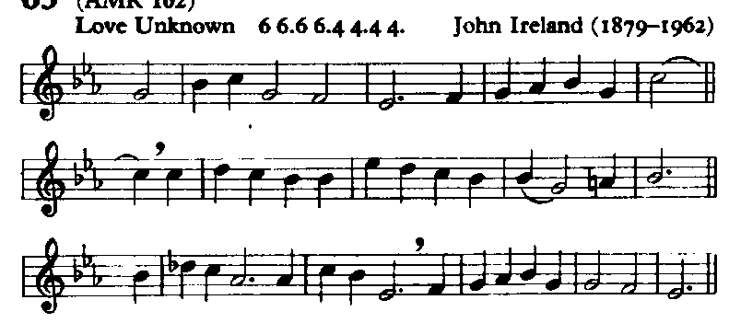

My song is love unknown,

my Saviour’s love to me,

love to the loveless shown,

that they might lovely be.

O who am I, that for my sake

my Lord should take frail flesh, and die?

# Leader 1: (1) JESUS IS CONDEMNED TO DEATH

Leader 1: We adore you, O Christ, and we bless you

All: For by your cross, you have redeemed and saved us.

Leader 1: 'Here is your King!' said Pilate to the Jews. Take him away, take him away!' they said. 'Crucify him!' *(Jn 19:15).*

Leader 2:Today we condemn Jesus to death in: the physically handicapped, the blind, the hearing impaired, those with learning difficulties, the elderly. We fail to make them full members of our communities.

Leader 3: Lord, you call us to protect these least of our brothers and sisters. Forgive us for the times when we have been like the crowd shouting 'crucify him, crucify him'.

He came from his blest throne,

salvation to bestow;

but men made strange, and none

the longed-for Christ would know.

But O, my Friend indeed, my Friend indeed,

who at my need his life did spend!

# Leader 1: (2) JESUS TAKES UP HIS CROSS

Leader 1: We adore you, O Christ, and we bless you

All: For by your cross, you have redeemed and saved us.

Leader 1: They then took charge of Jesus, and carrying his own cross he went out of the city to the skull, or as it is called in Hebrew, Gologtha. *(John 19:17)*

Leader 2: Let us think of all those who bear crosses: women who have been raped and must live with that memory; parents whose children have learning difficulties; a family in which the bread-winner has been made redundant and is unable to find another job; children with alcoholic parents.

Leader 3: We pray for all those who bear crosses. May they experience Jesus walking with them as they struggle with their cross.

Sometimes they strew his way,

and his sweet praises sing;

resounding all the day

hosannas to their King.

Then ‘Crucify!’ is all their breath,

and for his death they thirst and cry.

# Leader 1: (3) JESUS FALLS THE FIRST TIME

Leader 1: We adore you, O Christ, and we bless you

All: For by your cross, you have redeemed and saved us.

Leader 1: For though the virtuous man falls seven times, he stands up again, the wicked are the ones who stumble in adversity. *(Prov 24:16).*

leader 2: Let us think of people who experience their first fall: husbands or wives who have been unfaithful to their partners; public figures who preach high ideals and yet are weak in some area of their private lives; someone who enters politics or trade unionism and then finds himself making compromises.

Leader 3: We pray for all those who have experienced their first fall. May the first fall of Jesus remind them that they need not give up their high ideals. May they accept the challenge to stand again.

Why what hath my Lord done?

What makes this rage and spite?

He made the lame to run,

he gave the blind their sight.

Sweet injuries! yet they at these

themselves displease, and ‘gainst him rise.

# Leader 1: (4) JESUS MEETS HIS MOTHER

Leader 1: We adore you, O Christ, and we bless you

All: For by your cross, you have redeemed and saved us.

Leader 1: Near the cross of Jesus stood his mother and his mother's sister, Mary the wife of Clopas, and Mary of Magdala.  *(John 19:25)*

Leader 2: Mary lives in the afflicted mothers who watch their children carry a cross: mothers who see their children go to prison or even condemned to death; mothers who watch their children die from illness; mothers who watch while their children are misunderstood, unfairly criticized and humiliated; mothers whose children are drug addicts, homosexuals, or lesbians.

Leader 3: Lord, we thank you for the Marys of today, the courageous women whom you call to stand by the cross on which their children are being crucified.

They rise, and needs will have

my dear Lord made away;

a murderer they save,

the Prince of Life they slay.

Yet cheerful he to suffering goes,

that he his foes from thence might free.

# Leader 1: (5) SIMON OF CYRENE HELPS JESUS CARRY HIS CROSS

Leader 1: We adore you, O Christ, and we bless you

All: For by your cross, you have redeemed and saved us.

Leader 1: As they were leading him away they seized on a man, Simon from Cyrene, who was coming in from the country, and made him shoulder the cross and carry it behind Jesus. *(Luke 23:26)*

Leader 2: Let us think of those who are Simon of Cyrene today: teachers who give extra attention to slow learners; the worker who is Simon of Cyrene for his or her fellow-workers; groups who are Simon of Cyrene to the young people who have been considered failures; organizations which provide for the homeless; countries which assist other countries in times of natural disasters.

Leader 3: We thank you. Lord, for calling on men and women to shoulder the cross and carry it behind Jesus. We thank you that they answer this call with courage and dignity.

In life, no house, no home

my Lord on earth might have;

in death, no friendly tomb

but what a stranger gave.

What may I say? Heaven was his home;

but mine the tomb wherein he lay.

# Leader 1: (6) VERONICA WIPES THE FACE OF JESUS

Leader 1: We adore you, O Christ, and we bless you

All: For by your cross, you have redeemed and saved us.

Leader 1: 'But you', he said, 'who do you say I am?' *(Luke 9:20)*

Leader 2: We would like to live at peace with all, we want a good life without conflict. Veronica preserves on her towel the disfigured face of Jesus. She is the preacher who shows up our compromises, the hungry children, the disfigured bodies we see on the TV, the people we have hurt because we took the easy way out. Hide from it as we try, Veronica still shows the world the face of Jesus.

Leader 3: We pray for all those who must be Veronicas in the world today. Give them courage to preserve the towel and be always ready to show the true face of Jesus to those who seek him.

Here might I stay and sing:  
no story so divine;

never was love, dear King,

never was grief like thine!

This is my Friend, in whose sweet praise

I all my days could gladly spend.

# Leader 1: (7) JESUS FALLS FOR THE SECOND TIME

Leader 1: We adore you, O Christ, and we bless you

All: For by your cross, you have redeemed and saved us.

Leader 1: It was essential that he should in this way become completely like his brothers so that he could be a compassionate and trustworthy high priest of God's religion, able to atone for human sins. *(Hebrews 2:17)*

leader 2: In this fall Jesus experiences the weakness of his brothers and sisters: we see in him people of power who freely choose to walk with little people, sharing their frustrations; the adults who confess their mistakes and failures to the young, and ask for their forgiveness and encouragement; in Church leaders who search for the truth along with everyone else, experiencing pain and the anxieties that are common to all; teachers who toil side by side with their students, helping and being helped by them.

Leader 3: We thank you. Lord, for those leaders who keep alive in the world today Jesus' way of authority. We pray especially for the Church that in our communities Jesus may be the model for all leaders.

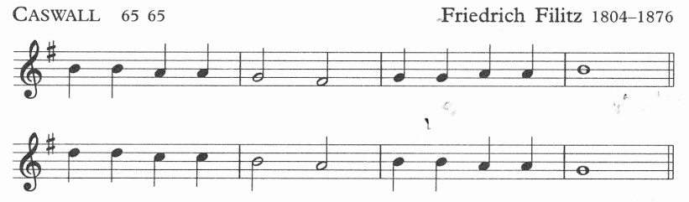

Glory be to Jesus,

who, in bitter pains,

poured for me the life-blood

from his sacred veins.

# Leader 1: (8) JESUS SPEAKS TO THE WOMEN OF JERUSALEM

Leader 1: We adore you, O Christ, and we bless you

All: For by your cross, you have redeemed and saved us.

Leader 1: Large numbers of people followed him, and of women too, who mourned and lamented for him. But Jesus turned to them and said: 'Daughters of Jerusalem, do not weep for me; weep rather for yourselves and for your children'. *(Luke 23:27-28)*

Leader 2: Let us think of those today who turn to us with the message 'weep not for me; weep rather for yourselves and for your children': the persons afflicted with a terminal illness whose spirit is not crushed but who teach us, the strong and the healthy, how to treasure the gift of life; a blind person who shows us that we are closing our eyes to the truth; the family that chooses to live a simple life-style and must face the scepticism of friends and relatives, but their way of life challenges our consumer society.

Leader 3: We thank you, Lord, for those people who, when we would console them, turn and challenge us to examine our lives.

Grace and life eternal

in that blood I find;

blest be his compassion

infinitely kind.

# Leader 1: (9) JESUS FALLS THE THIRD TIME

Leader 1: We adore you, O Christ, and we bless you

All: For by your cross, you have redeemed and saved us.

Leader 1: ‘I have toiled in vain, I have exhausted myself for nothing’ *(Isaiah 49:4)*

Leader 2: Jesus is falling today in those who are being crushed by others: people who live under dictatorships; battered wives; children habitually abused by their parents or guardians; people so insulted and rejected that they have neither self-confidence nor self-respect.

Leader 3: Lord, we pray for all those who remain in despair by the weight of their cross. We pray that, like Jesus, they may get up again knowing their cause is with the Lord and their reward with God.

Blest through endless ages

be the precious stream,

which from endless torments

did the world redeem.

# Leader 1: (10) JESUS IS STRIPPED OF HIS GARMENTS

Leader 1: We adore you, O Christ, and we bless you

All: For by your cross, you have redeemed and saved us.

Leader 1: When they had finished crucifying him they shared out his clothing by casting lots. *(Matthew 27:35)*

Leader 2: Today Jesus is stripped of his garments whenever people are stripped of their dignity: children made to feel failures by parents because they fail their examination; elderly people when they are treated harshly at government offices; people whose culture was looked down upon by the Church and the colonising countries.

Leader 3: Forgive us for the time when we too strip others of their dignity. You call us to clothe the naked. Help us to be people who encourage others to grow in awareness of their dignity as children if God.

Abel’s blood for vengeance

pleaded to the skies;

but the blood of Jesus

for our pardon cries.

# Leader 1: (11) JESUS IS NAILED TO THE CROSS

Leader 1: We adore you, O Christ, and we bless you

All: For by your cross, you have redeemed and saved us.

Leader 1: The people stayed there watching him. As for the leaders, they jeered at him. 'He saved others', they said, ‘let him save himself if he is the Christ of God, the Chosen One'. *(Luke 23:35-36)*

Leader 2: Let us think of those who have been nailed to a cross: the worker who tries to organize his colleagues and is therefore victimized, the female employee who refuses to give in to the advances of her boss and suffers victimization or loses her job; those imprisoned for their commitment to a freedom and justice.

Leader 3: Lord, we thank your for those people whom you have called to be nailed to the cross. Forgive us for the times when we too have been among the leaders jeering at them.

Oft as it is sprinkled

on our guilty hearts,

Satan in confusion

terror-struck departs.

***Walk TWO stations (omit 12 Jesus speaks to his mother) to:***

# Leader 1: (13) JESUS DIES ON THE CROSS

Leader 1: We adore you, O Christ, and we bless you

All: For by your cross, you have redeemed and saved us.

Leader 1: 'Father, into your hands I commit my spirit'. With these word breathed his last. *(Luke 23:46)*

Leader 2: Let us think of those who, like Jesus, have died on a cross: martyrs like Mahatma Gandhi, Martin Luther King, Archbishop Romero, Maximilian Kolbe; our ancestors who died struggling against their oppressors, the silent prophet, the artist, the craftsman/woman whose talents have died under the cross of cultural domination.

Leader 3: Lord, we thank you for the witness of these people. We thank you that they, having lived and died like Jesus, have become a source of life for us.

Lift ye then your voices;

swell the mighty flood;

louder still and louder

praise the precious blood.

# Leader 1: (13/14) JESUS IS TAKEN DOWN FROM THE CROSS

**AND PLACED IN THE TOMB**

Leader 1: We adore you, O Christ, and we bless you

All: For by your cross, you have redeemed and saved us.

Leader 1: Having been assured of Jesus’ death by the centurion, Pilate granted the corpse to Joseph who bought a shroud, took Jesus down from the cross, wrapped him in the shroud and laid him in a tomb which had been hewn out of the rock. *(Mark 15:45-46)*

Leader 2: Let us think of those today who have been taken down from their own cross and placed in a tomb: parents in their old age abandoned by their children, and who now see the sacrifices they made as futile; workers suddenly made redundant after working for a company for over twenty years; people in places like Northern Ireland and the Middle East who live daily with war and who see no immediate prospect of peace.

Leader 3: Lord, teach us what it is to endure in faith the emptiness of the tomb. Save us from despair. Help us to realise that it is in silence and darkness, in the womb and in the earth, that new life forms.

***[Where these Stations are part of a celebration of the EUCHARIST, please turn to page 15; otherwise continue as follows]***

*Everyone returns to their place in the Lady Chapel for the conclusion:*

Glory be to Jesus,

who, in bitter pains,

poured for me the life-blood

from his sacred veins.

Leader 1: Terrified, the women lowered their eyes. But the two men said to them, 'Why look among the dead for someone who is alive? He is not here, he has risen.'  *(Luke 24:5-6)*

Leader 2: It won’t be long before Jesus rises from the dead in:

* + - former drug addicts who now assist in rehabilitation programmes;
    - a backward student who, through the attention of a concerned and dedicated teacher, discovers that he or she can live creatively with their cross whatever it may be.

Leader 1: Through the cross you brought joy into the world

All: We worship you Lord, we venerate your cross, we praise your resurrection.

Leader 3: We thank you. Lord, for the resurrection moments of our lives - the times of hope and joy when we can truly exclaim, 'He is not here, he has risen!’

Priest: Christ give us grace to grow in holiness, to deny ourselves, take up our cross, and follow him; and the blessing of God almighty, the Father, the Son and the Holy Spirit, be among us and remain with us always. **Amen**

*We remain kneeling for the final hymn*

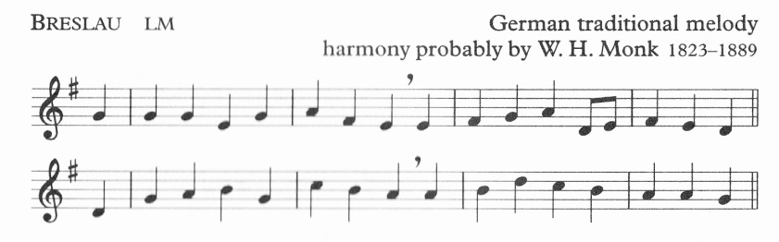

Take up thy cross, the Saviour said,

if thou wouldst my disciple be;

deny thyself, the world forsake,

and humbly follow after me.

To thee, great Lord, the One in Three,

all praise for evermore ascend:

O grant us in our home to see

the heavenly life that knows no end.

***When these Stations are followed by a celebration of the Eucharist:***

*As we return to our pews, we sing:*

Take up thy cross, the Saviour said,

if thou wouldst my disciple be;

deny thyself, the world forsake,

and humbly follow after me.

To thee, great Lord, the One in Three,

all praise for evermore ascend:

O grant us in our home to see

the heavenly life that knows no end.

All We do not presume to come to this your table, merciful Lord, trusting in our own righteousness, but in your manifold and great mercies. We are not worthy so much as to gather up the crumbs under your table. But you are the same Lord whose nature is always to have mercy. Grant us therefore, gracious Lord, so to eat the flesh of your dear Son Jesus Christ and to drink his blood, that our sinful bodies may be made clean by his body and our souls washed through his most precious blood, and that we may evermore dwell in him, and he in us. Amen.

The service continues with the Eucharistic Prayer on page 6 of the other sheet.

**Fifteenth Station (see page 13)**

**JESUS RISES FROM THE DEAD**

Terrified, the women lowered their eyes. But the two men said to them, 'Why look among the dead for someone who is alive? He is not here, he has risen.' (Luke 24:5-6)

# Meditation

Today Jesus rises from the dead in: former drug addicts who now assist in rehabilitation programmes; a backward student who, through the attention of a concerned and dedicated teacher, discovers that he or she can live creatively with their cross whatever it may be.

# Prayer

We thank you. Lord, for the resurrection moments of our lives - the times of hope and joy when we can truly exclaim, 'He is not here, he has risen!’